
RHEB (Y35N)
Catalog Number: CR-M26338
Gene Symbol: RHEB
Description: Anti-RHEB (Y35N) Mouse Monoclonal Antibody

Background: RheB (Ras Homolog Enriched in Brain) is an evolutionarily conserved member of the Ras-family of small GTP-binding proteins
originally found to be rapidly induced by
synaptic activity in the hippocampus following seizure. While it is expressed at relatively high levels in the brain, RheB is widely expressed in other tissues and may be induced by growth
factor stimulation. RheB has an important role in regulating the insulin/TOR signaling pathway.
The mammalian target of rapamycin, mTOR, is a serine/threonine protein kinase that acts as a
sensor for ATP and amino acids, balancing the availability of nutrients with translation and cell growth. The tuberin/hamartin (TSC2/TSC1)
complex inhibits mTOR activity indirectly by inhibiting RheB via tuberin's GAP activity.
Immunogen: A synthetic peptide from the internal region of RHEB which includes the mutation of Y35N, human origin.
Tested applications: ELISA, WB, IHC Recommended dilutions:
ELISA: 1:1000-1:2000
WB: 1:500-1:1000
IHC: 1:50-1:100
Concentration: 1 mg/ml
Host: Mouse
Clonality: Monoclonal
Purity: Purified from ascites
Format: Liquid

Storage buffer:
Preservative: no
Constituents: PBS (without Mg2+ and Ca2+), pH 7.4, 150 mM NaCl, 50% glycerol
Species Reactivity: Recognizes Y35N mutant, but not wild-type RHEB of vertebrates.
Storage Conditions: Store at -20°C. Avoid freeze / thaw cycles.
Western blot:
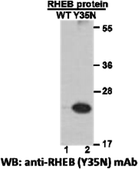

Western blot analysis of recombinant RHEB (Y35N) and wildtype proteins. Purified
His-tagged RHEB (Y35N) protein (lane2) and corresponding wild-type protein (lane1) were blotted with anti-RHEB (Y35N) monoclonal antibody (Cat. #26338).

For research use only. Not for diagnostic or therapeutic applications.

Immunofluorescence:
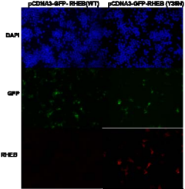
Immunofluorescence of cells expressing RHEB proteins with anti-RHEB (Y35N) antibody.
HEK293T cells were transfected with
pCDNA3-GFP-RHEB (WT) plasmid (left
column) or pCDNA3-GFP-RHEB (Y35N)
plasmid (right column), then fixed and stained with anti-RHEB (Y35N) monoclonal antibody (Cat. #26338).

科博瑞（武汉）生物科技有限公司
TEL：027-87615885 15972062685
- mail：3636901710@qq.com
Web:www.coburybio.com

